Table of Content

Term of reference
  - Title
  - Description
  - Objectives

Methodology and algorithm

Program flow and user manual

Term of reference

  - Title

Internationalized ATM System

  - Description

Develop an internationalized ATM program, which can deposit or withdraw money from an user account. Each transaction will record into log file. The user interface locale can change depending on the type of users, which can be specified at the time of program invocation. Different currencies can also be selected by the user as an input parameter when the program starts.

  - Objectives

The scope of the program is to provide more feasible and user-friendly internationalized interface for the user during accessing ATM services.

Methodology and algorithm

We have used the following algorithm for the program design:

- Boolean ValidateUser() – this function is used to determine the valid user account which mean that they have already opened the account.
- Void openAccount(loginid,currency) – this function is used to open the account frame depend on the login_id and different currency.
- Double cal(balance,amount,action) – this function is used to calculate the balance after either they deposit or withdraw the money at the specific account.
- Void changelang() – this function is used to change the language of user interface depend on the different type of user.
- Double getbalance(loginid) – this function is used to retake the balance from the user account file.
- Void setbalance(loginid, balance) – this function is used to rewrite the balance into the user account file after they finish the transaction.
- Void writelog() – this function is used to record the transaction into the log file for account maintenance.

Program flow and user manual

- A login frame, which asks for the login and the password of the user.
- Verify the input password with the one, which stores in the user account file.
- If passwords match and select correct currency of account, then open the account frame else goes back to step 1.
- User can process a transaction (deposit or withdraw) in the account frame.
- If the transaction is valid, then update the user account file and save log.

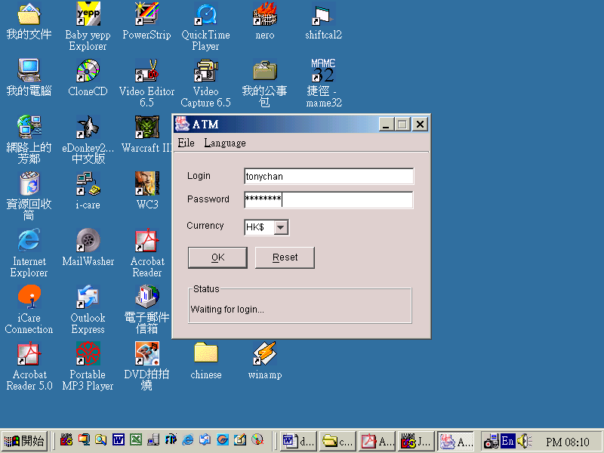

Step 1: A login frame, which asks for the login and the password of the user. You can select the different language type of user interface from the pull-down menu. Then you may select correct currency for the account. E.g. if you have only HK dollar currency account but you select other currency, the program cannot allow to perform this actions.

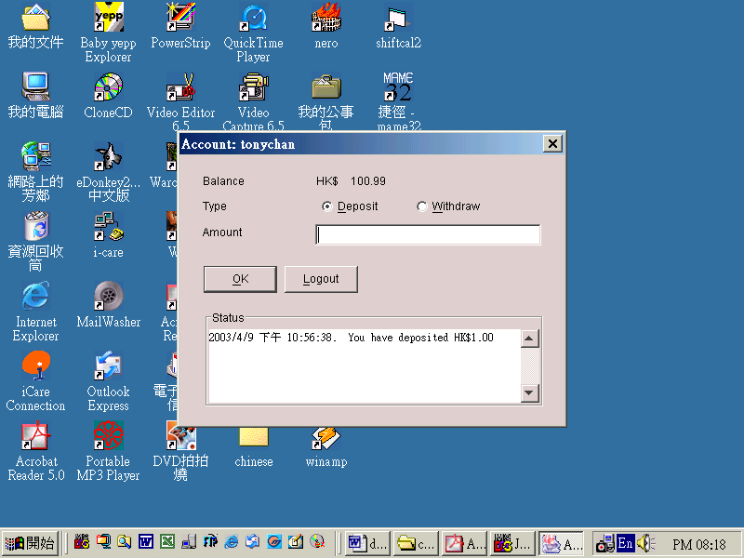

Step 2: Verify the input password with the one, which stores in the user account file.
If passwords match and select correct currency of account, then open the account frame else goes back to step 1.
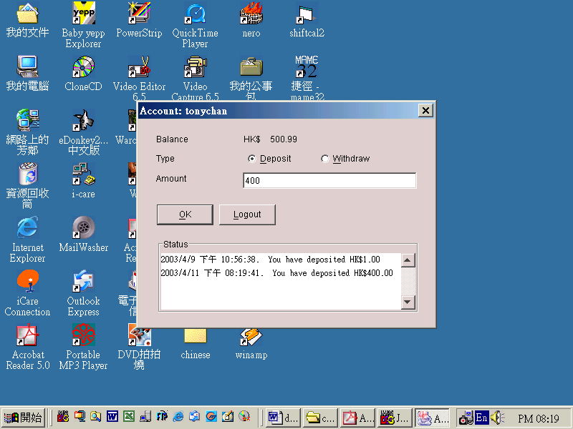

Step 3: User can process a transaction (deposit or withdraw) in the account frame.
If the transaction is valid, then update the user account file and save log.

Course/year : COMP423

Course Unit : Assignment 1

Team Member : Luk Kwok Chi (02532640t)
: Tam Koon Wing (02706110t)
: Cheng Wai Hung (02703340t)

Title : Internationalized Software Development

Page : 8 (include this cover page)

